SpacePoint Instructors Payment and Certificate
Step 1: Calculate the number of sessions that the instructor has delivered
Step 2: Fill the following in the instructors payment letter:
- Date of sending the letter
- Name of Instructor
- Session/Course/Program delivery date/s
- Workshop Description
- Role (Lead Facilitator or Facilitator)
- Location
- Duration
- Compensation (Direct payment through the delivery of the sessions (payment/session x no. of sessions)
- Bonus (Anything that they paid (posters, certificates printings, etc) or performance bonuses)
- Facilitators bank details
- Place for Instructor Signature
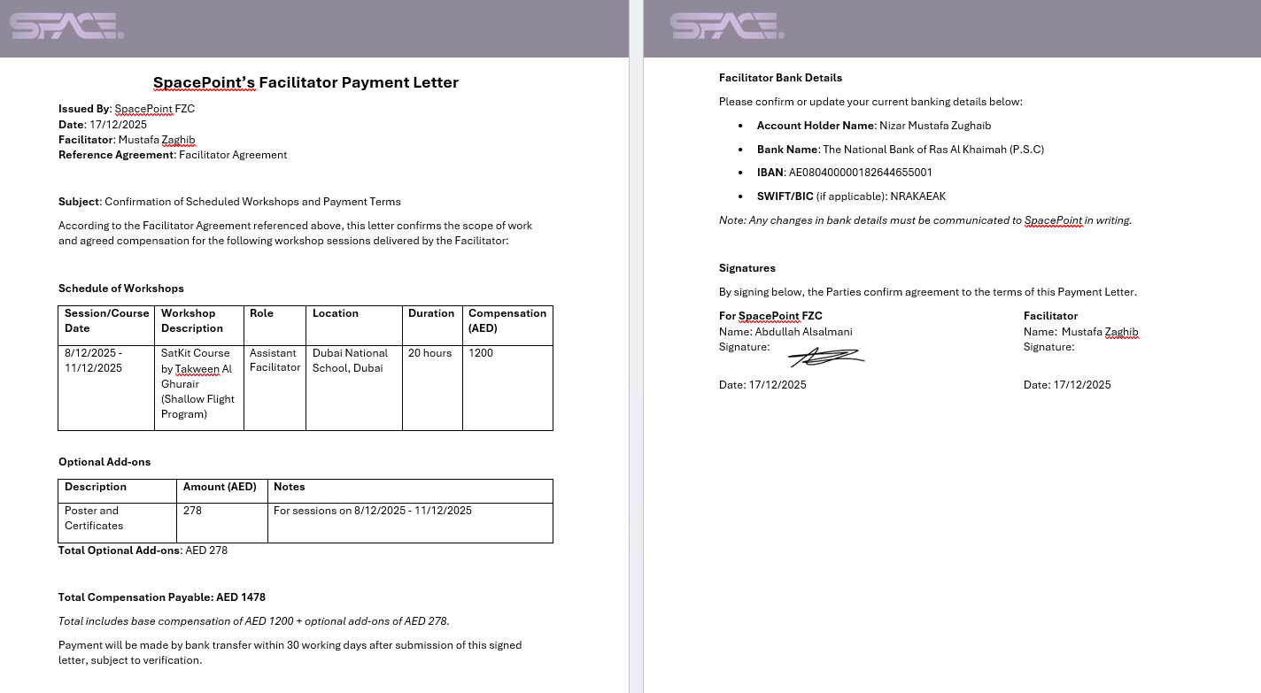

Step 3: Create/Generate the certificate
- Name of Instructor
- Name of Session/Course/Program / Can be the Workshop Description
- Session/Course/Program delivery date/s
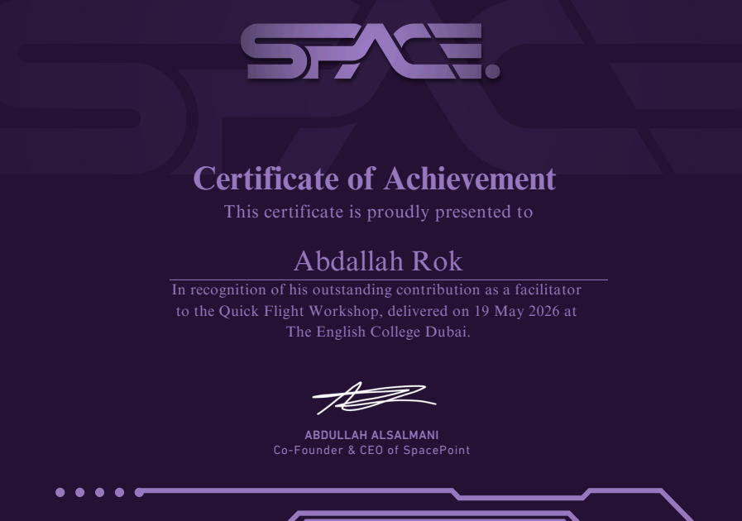
- Location

Step 4: Send for instructor’s signature alongside the certificate

